# How To Install?

## Step 1: Copy Files On The Server

If you are using Xamp than you have to copy file to the “xamp/htcdoc” folder.

If you are uploading on server than copy those file on “public_html” folder on server or what ever your root folder is.

## Step 2: Import Database Using PHPMyAdmin

This is how PhpMyAdmin Look like. These is import button on top click this.

### Click Import

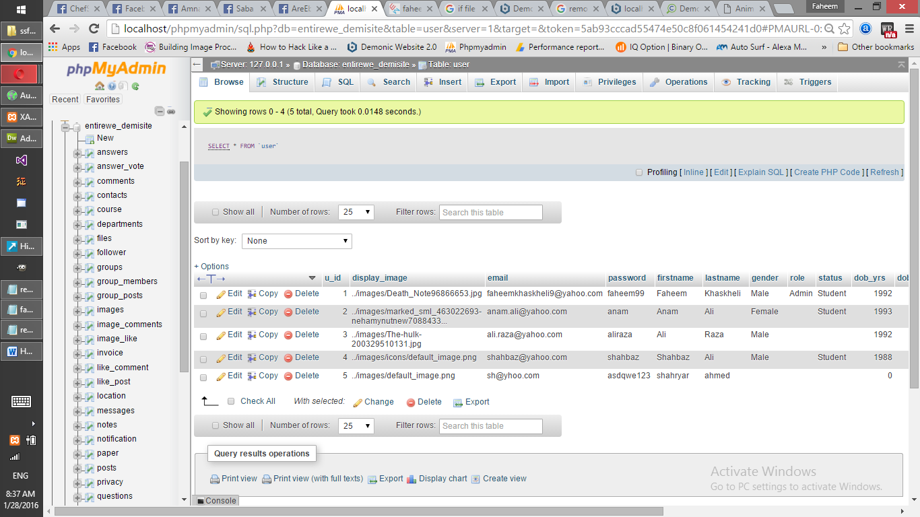

### Chose File From CD (‘Database/database.sql’)

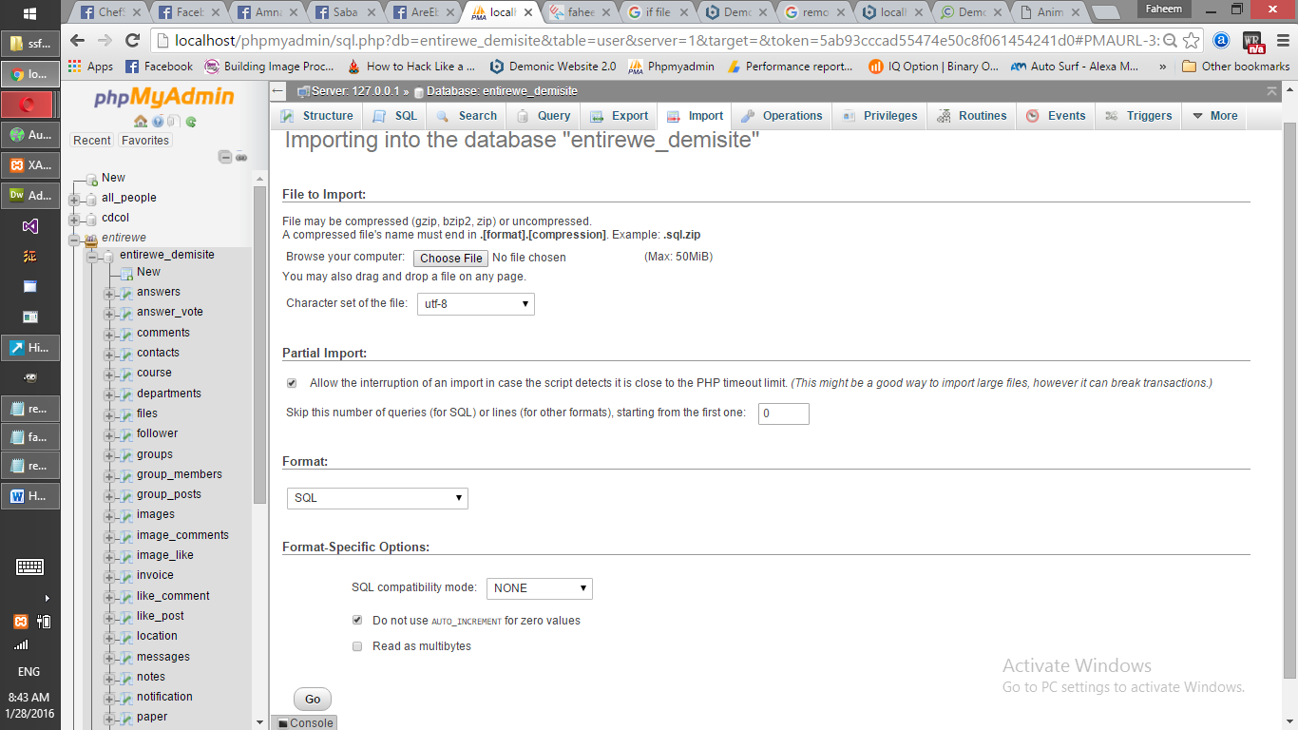

## Step 3: Open SSFWS/install.php

This is our Database

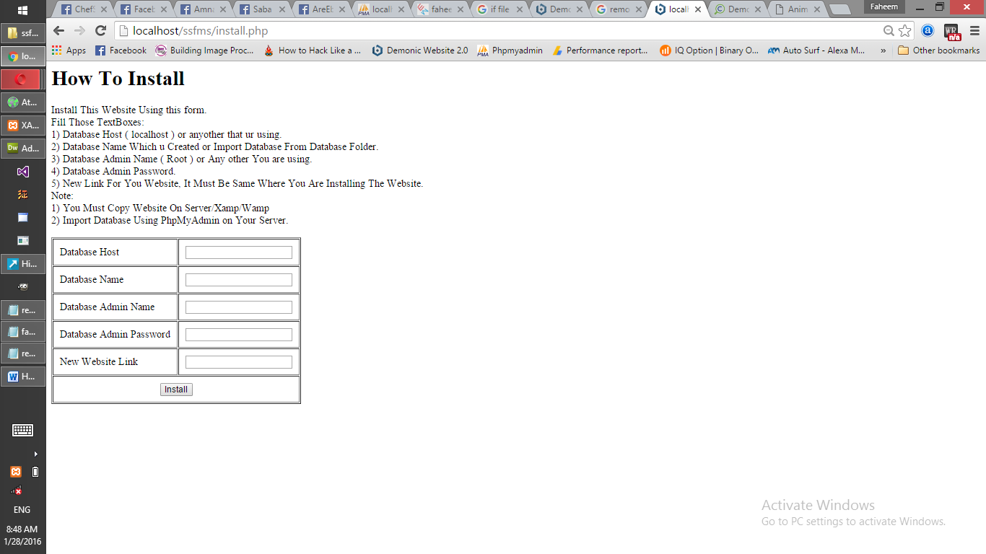

Here we are using Link as “localhost/ssfms/install.php” but you will write your own link if its is on localhost than its ok. Otherwise “ <http://mylink.com/install.php> ”



Fill Form and than use Website.

